#### Inheritance EG. 2: The Point2D and Point3D Classes

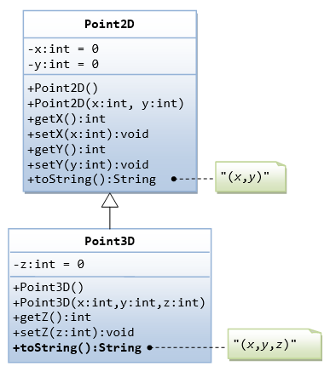

|  |  |
| --- | --- |
| 1  2  3  4  5  6  7  8  9  10  11  12  13  14  15  16  17  18  19  20  21  22  23  24  25  26  27  28  29  30  31  32  33  34 | /*  * A test driver for the Point2D and Point3D classes  */  public class TestPoint2DPoint3D {  public static void main(String[] args) {  /* Test Point2D */  // Test constructors and toString()  Point2D p2a = new Point2D(1, 2);  System.out.println(p2a); // toString()  Point2D p2b = new Point2D(); // default constructor  System.out.println(p2b);  // Test Setters and Getters  p2a.setX(3); // Test setters  p2a.setY(4);  System.out.println(p2a); // toString()  System.out.println("x is: " + p2a.getX());  System.out.println("x is: " + p2a.getY());  /* Test Point3D */  // Test constructors and toString()  Point3D p3a = new Point3D(11, 12, 13);  System.out.println(p3a); // toString()  Point2D p3b = new Point3D(); // default constructor  System.out.println(p3b);  // Test Setters and Getters  p3a.setX(21); // in superclass  p3a.setY(22); // in superclass  p3a.setZ(23); // in this class  System.out.println(p3a); // toString()  System.out.println("x is: " + p3a.getX()); // in superclass  System.out.println("y is: " + p3a.getY()); // in superclass  System.out.println("z is: " + p3a.getZ()); // in this class  }  } |

**Inheritance EG. 3: Superclass Person and its Subclasses**

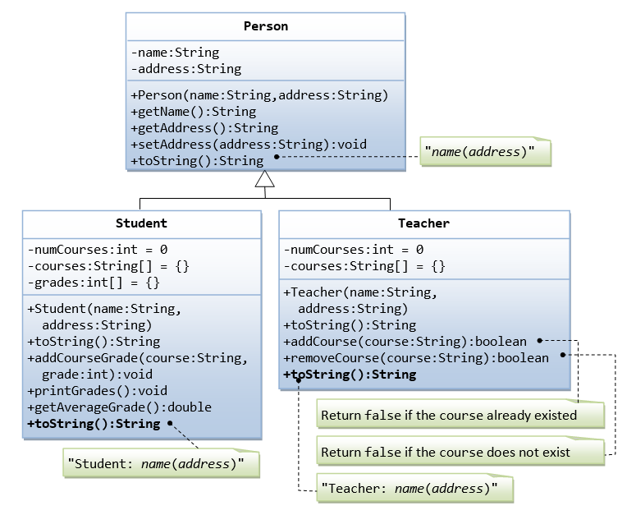

/*

* A test driver for Person and its subclasses.

*/

public class **TestPerson** {

public static void main(String[] args) {

/* Test Student class */

Student s1 = new Student("Tan Ah Teck", "1 Happy Ave");

s1.addCourseGrade("IM101", 97);

s1.addCourseGrade("IM102", 68);

s1.printGrades();

System.out.println("Average is " + s1.getAverageGrade());

/* Test Teacher class */

Teacher t1 = new Teacher("Paul Tan", "8 sunset way");

System.out.println(t1);

String[] courses = {"IM101", "IM102", "IM101"};

for (String course: courses) {

if (t1.addCourse(course)) {

System.out.println(course + " added.");

} else {

System.out.println(course + " cannot be added.");

}

}

for (String course: courses) {

if (t1.removeCourse(course)) {

System.out.println(course + " removed.");

} else {

System.out.println(course + " cannot be removed.");

}

}

}

}

Tan Ah Teck(1 Happy Ave)

Tan Ah Teck

8 Sunrise Place

Student: Mohd Ali(8 Kg Java)

Mohd Ali

9 Kg Satu

Student: Mohd Ali(9 Kg Satu) IM101:97 IM102:68

Average is: 82.5

Teacher: Paul Tan(8 sunset way)

IM101 added.

IM102 added.

IM101 cannot be added.

IM101 removed.

IM102 removed.

IM101 cannot be removed.

#### Ex: Superclass Shape and its subclasses Circle, Rectangle and Square

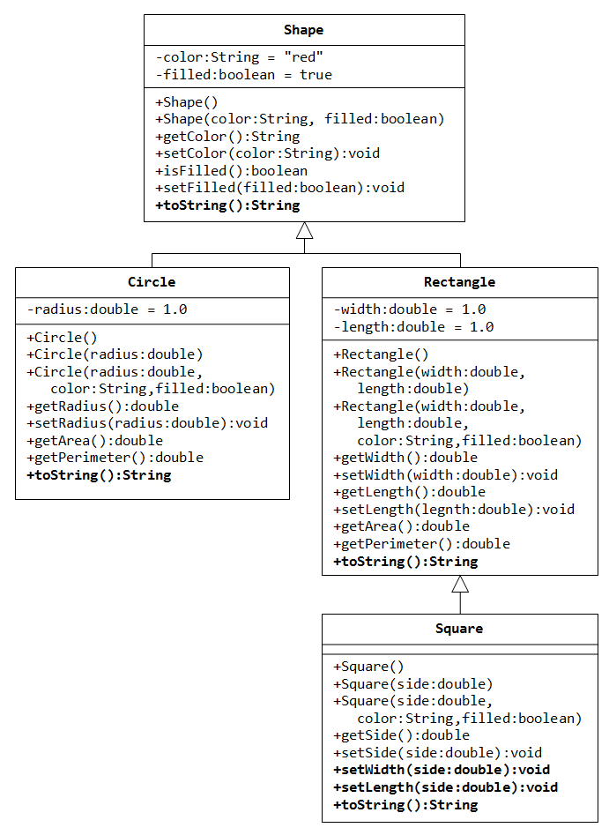

a) Write a superclass called Shape (as shown in the class diagram), which contains:

* Two instance variables color (String) and filled (boolean).
* Two constructors: a no-arg (no-argument) constructor that initializes the color to "green" and filled to true, and a constructor that initializes the color and filled to the given values.
* Getter and setter for all the instance variables. By convention, the getter for a boolean variable xxx is called isXXX() (instead of getXxx() for all the other types).
* A toString() method that returns "A Shape with color of xxx and filled/Not filled".

**Write a test program to test all the methods defined in Shape.**

b) Write two subclasses of Shape called Circle and Rectangle, as shown in the class diagram.

The Circle class contains:

* An instance variable radius (double).
* Three constructors as shown. The no-arg constructor initializes the radius to 1.0.
* Getter and setter for the instance variable radius.
* Methods getArea() and getPerimeter().
* Override the toString() method inherited, to return "A Circle with radius=xxx, which is a subclass of yyy", where yyy is the output of the toString() method from the superclass.

The Rectangle class contains:

* Two instance variables width (double) and length (double).
* Three constructors as shown. The no-arg constructor initializes the width and length to 1.0.
* Getter and setter for all the instance variables.
* Methods getArea() and getPerimeter().
* Override the toString() method inherited, to return "A Rectangle with width=xxx and length=zzz, which is a subclass of yyy", where yyy is the output of the toString()method from the superclass.

**Write a test program to test all the methods defined in Circle and Rectangle.**

c) Write a class called Square, as a subclass of Rectangle. Convince yourself that Square can be modeled as a subclass of Rectangle. Square has no instance variable, but inherits the instance variables width and length from its superclass Rectangle.

* Provide the appropriate constructors (as shown in the class diagram). Hint:
* public Square(double side) {
* super(side, side); // Call superclass Rectangle(double, double)

}

* Override the toString() method to return "A Square with side=xxx, which is a subclass of yyy", where yyy is the output of the toString() method from the superclass.
* Do you need to override the getArea() and getPerimeter()? Try them out.
* Override the setLength() and setWidth() to change both the width and length, so as to maintain the square geometry i.e. length = width.

**Write a test program to test all the methods defined in Square.**